ASSIGNMENT 1

Report

Language Used: Python

**TEST SUITE**

The following screenshot has all failed test attempts processed.

**TESTING EACH FUNCTION SEPERATELY**

**STRING TEST 1 UPPERCASE**

* **Graphical user interface, text, application, email

  Description automatically generated**Passed
* Failed

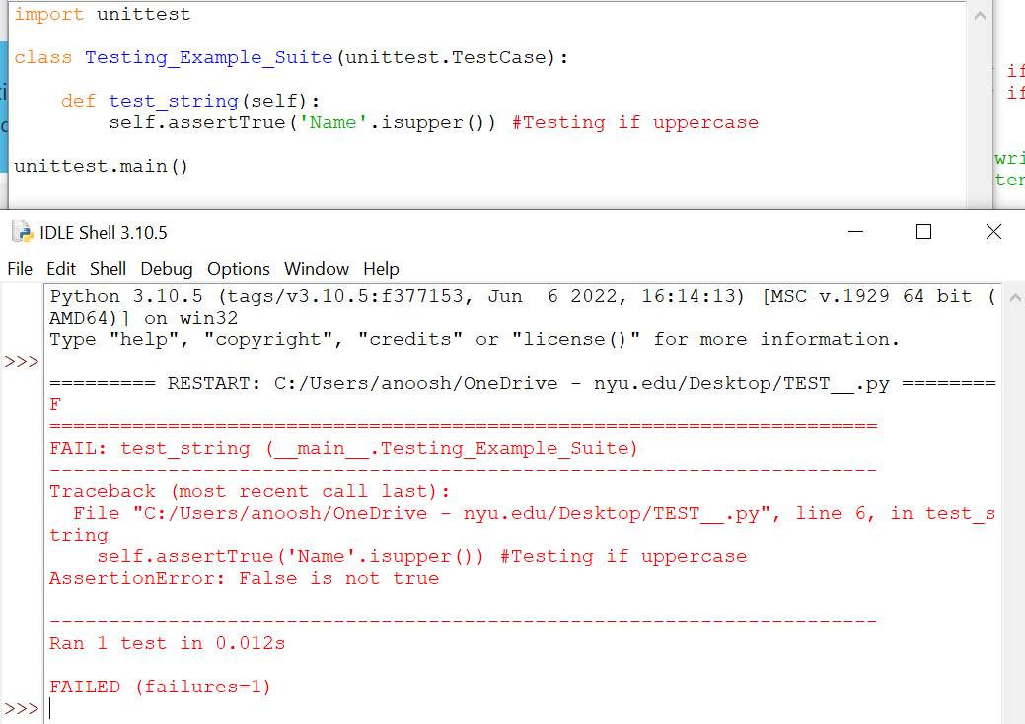

**STRING TEST 1 Written or not**

* Failed



**Addition**

* Passed

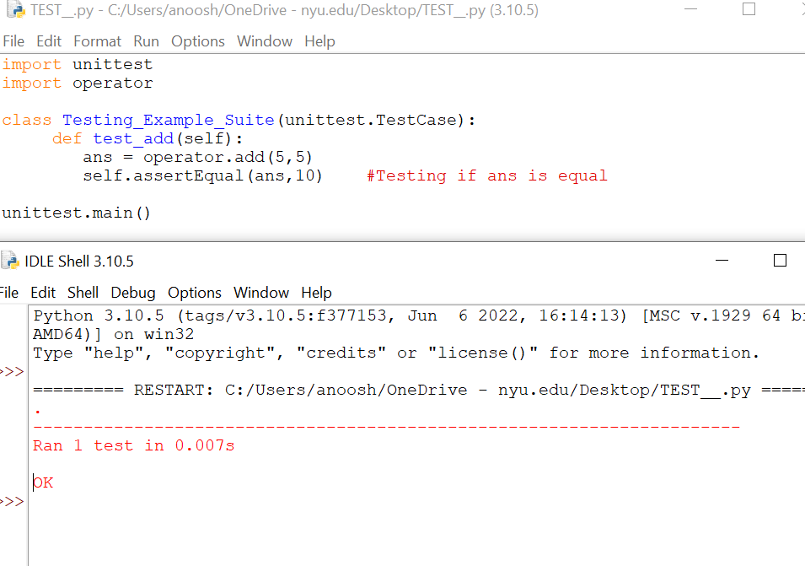

* Failed

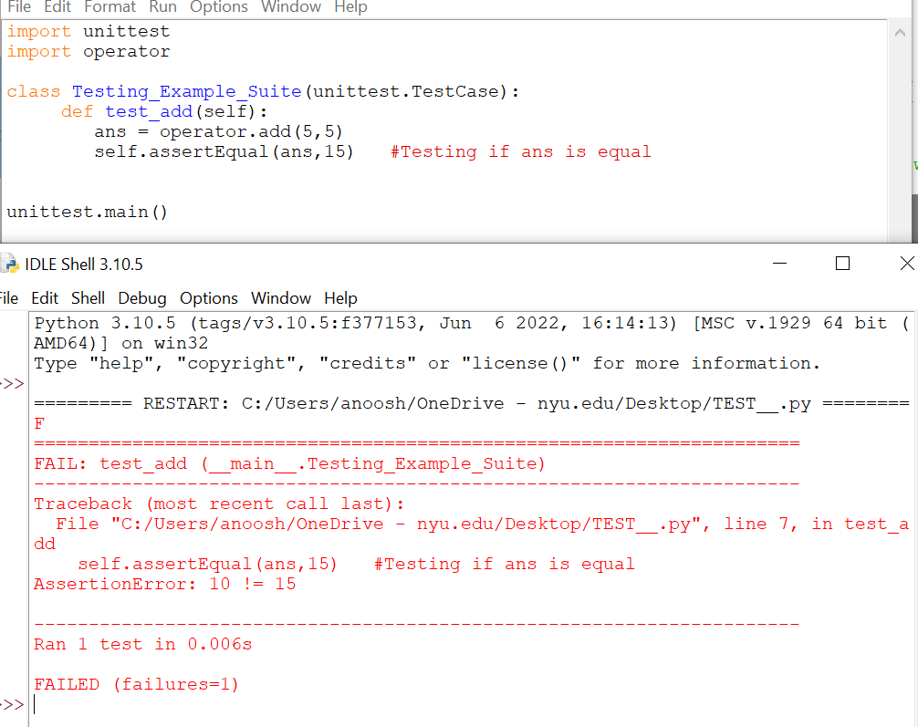

**SUBTRACTION**

* 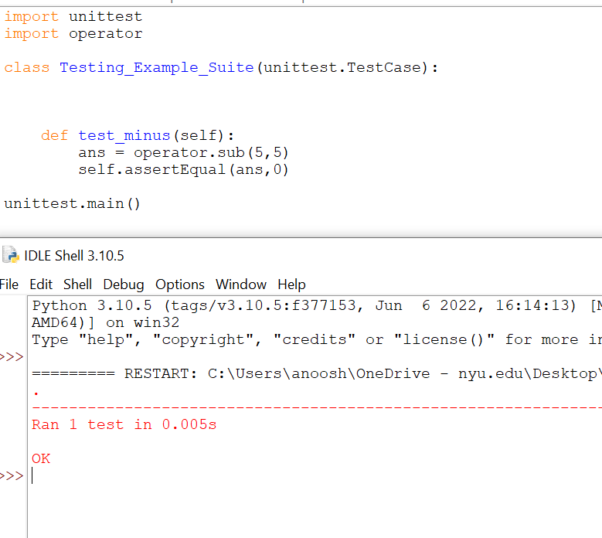Passed
* 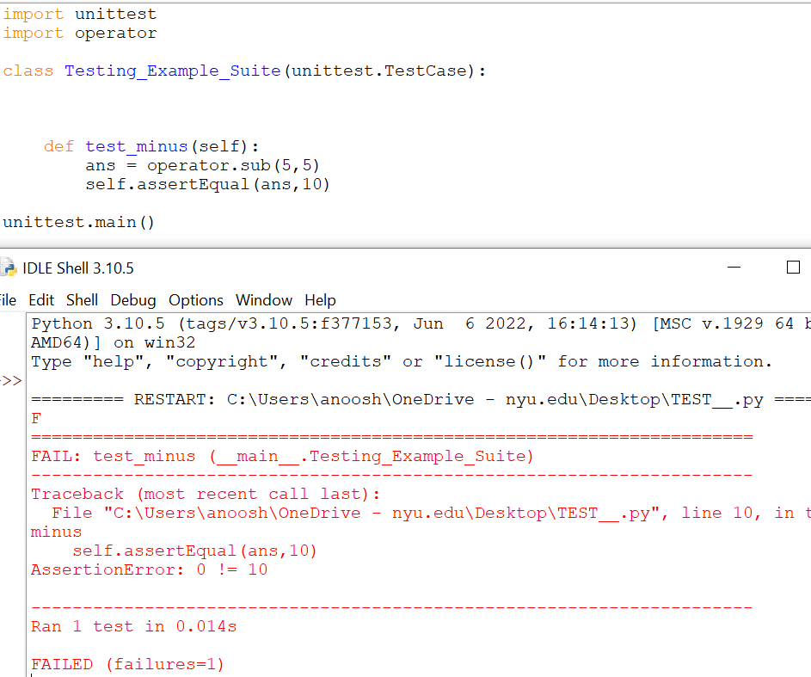Failed

**MULTIPLICATION**

* 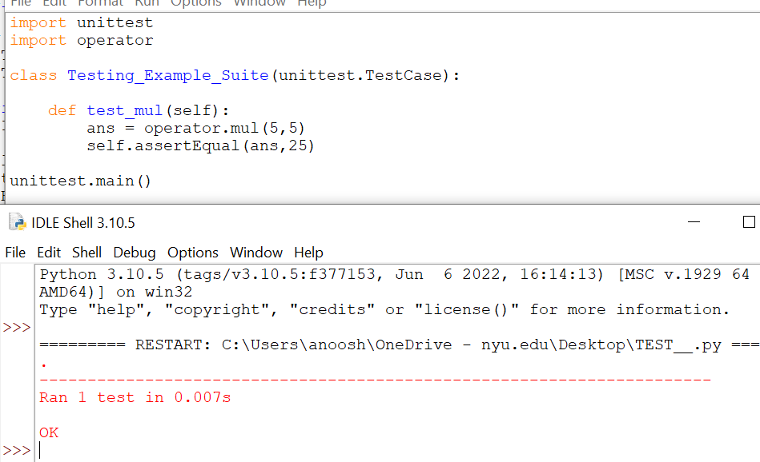Passed
* Graphical user interface, text, application, email

  Description automatically generatedFailed

**DIVISION**

* Graphical user interface, text, application, email

  Description automatically generatedPassed
* Failed

